SACRÉ CŒUR, QUELLE BELLE VUE!
Name……………………………… Class………………………………
Answer these questions after reading the information about Sacré Coeur.
- How long did it take to finish building Sacré Coeur?
………………………………………………………………………..
2) What is the meaning of Montmartre?
………………………………………………………………………...
3) Where would you go to get your portrait painted?
…….……………………………………………………………..........
4) What is the highest point in Paris?
……………………………………………………………………...
5) What colour is the famous windmill at the bottom of Sacré Coeur’s hill?
………………………………………………………………………...
6) What are 3 ways to get to the summit of the hill to see the church?
………………………………………………………………………….
7) Which famous people lived around the area during the 1800’s?
…………………………………………………………………………
8) Extra Question: Many people think that Sacré Coeur resembles a sweet dessert. Which dessert do you think they are referring to? (Answer not on webpage)
………………………………………………………………………….
- Copy and Paste a small image from the page to decorate your work.

UNSCRAMBLE THE WORDS WHICH ARE FOUND IN THE INFORMATION TO SOLVE THE FINAL PHRASE.
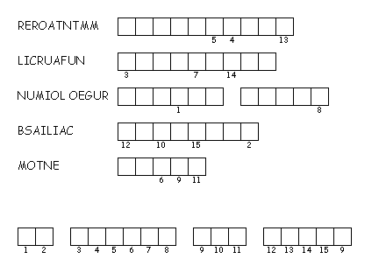
You can also fill out this Acrostic Poem to talk about what you have learned.
S……………………………………………………..
A…………………………………………………….
C……………………………………………………..
R……………………………………………………..
E……………………………………………………..
C………………………………………......................
O…………………………………………………......
E……………………………………………………..
U…………………………………………..................
R…………………………………………………………...

