Name:
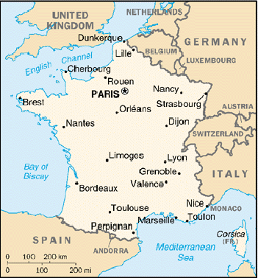
Les Châteaux.
Save this page to your H drive and open it in Word.

- What is a Château?
- Where are most of the Châteaux in France?
- What were the original Châteaux like and why?
- Why was the Loire Valley chosen by the French Kings for the location of their Châteaux?
- Chambord is the best known of all the Châteaux. Which King ordered its construction?
- About how old is the Château? How long did it take to build it?
- Why did the king invite Leonardo da Vinci to help him in this?
- What did people at that time think of the Château of Chambord?
- Describe the most special feature that Leonardo added to this Château.
- What was King François’ symbol? Why do you think he may have chosen this?
- Add here a section called: Amazing facts about the Château of Chambord. Place at least six interesting facts about the château in this section.
Include some pictures. You can find a good selection on the other web page:

Format your work and tidy up your page, deleting un-needed information. Check it is all on one page before checking with your teacher that you may print it out.

